PPH kits study: photo-based survey
Appendix 3 Consent form
Version 1 28th March 2024
To take part please read the following statements and, if you agree, select ‘Yes’.

I confirm that I have read and understood the participant information sheet [hyperlink will be added on Thiscovery] dated 28th March 2024 for this task. | 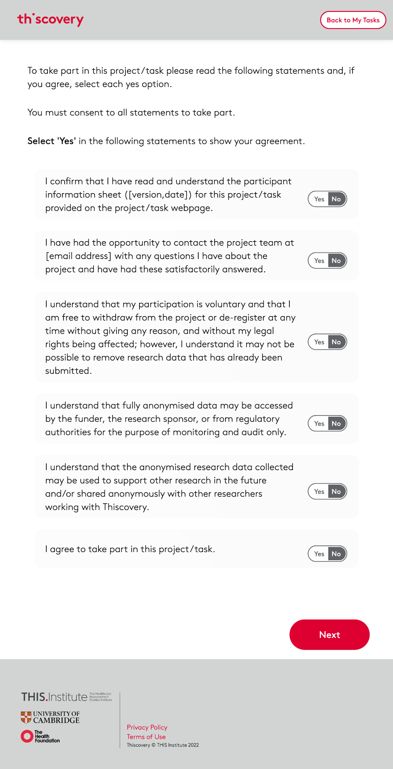
I have had the opportunity to contact the project team at
PPH-kits@thisinstitute.cam.ac.uk with any questions I have about the task and have had these answered satisfactorily.
I understand that my participation is voluntary and that I am free to withdraw or de-register at any time without giving any reason, and without my legal rights being affected; however, I understand it may not be possible to remove research data that has already been submitted.
I understand that anonymised data may be accessed by the funder (The Health Foundation), the research sponsor (University of Cambridge), or by regulatory authorities for the purpose of monitoring and audit only.
I understand that anonymised research data collected may be used to support other research in the future and/or shared anonymously with other researchers working with University of Cambridge.
I agree that anonymised data collected from the survey may be used in reports and publications arising from the project.
I agree to take part in this study.

You can take part even if you don't agree to the following statements.

I am happy to be contacted about future studies run by The Healthcare Improvement Studies Institute that may be of interest to me, and agree to my contact details being retained by The Healthcare Improvement Studies Institute for this purpose.

Version No: 1
Consent form date: 28th March 2024
IRAS ID/REC Ref No: [IRAS 340432 /REC Ref No]

